LAB 5: CONFIGURATION OF STATIC ROUTES AND DEFAULT ROUTES

OBJECTIVES
1. To understand the concept of Static Routing and Default Routing for manual path selection in a network.
2. To configure a network topology using Cisco Packet Tracer that connects different networks using Static and Default routes to visualize the flow of packets between different networks.

SOFTWARE AND HARDWARE REQUIREMENTS
1. Cisco Packet Tracer (Version 6.2 or higher)
2. Windows PC/Laptop

THEORY
1. Static Routing
Static routing is the practice of manually configuring routing entries in the router's routing table. It involves the network administrator defining the specific path that data packets must take to reach a destination network.
Operation: Static routing works by using the command:
ip route [destination_network] [subnet_mask] [next_hop_address]
The router examines this manual entry to determine where to forward the packet. If the link fails, the administrator must manually update the route.
Application: Static routing is used in small networks where the topology is simple and does not change frequently. It is also employed for security purposes to hide parts of a network from discovery.
2. Default Routing
Default routing is a specific type of static routing that functions as a "gateway of last resort." It enables the router to forward all packets to a specific next-hop router if the destination network is not found in the routing table.
Operation: Default routing involves configuring a route with all zeros:
ip route 0.0.0.0 0.0.0.0 [next_hop_address]
This instructs the router to send any unknown traffic to the specified neighbor router.
Application: Default routing is used primarily in stub networks (networks with only one exit path) or to connect a network to the Internet via an Internet Service Provider (ISP). It significantly reduces the size of the routing table.

NETWORK TOPOLOGY
A topology was created using two routers: "Router 0" and "Router1". These routers are connected via a serial link. Switch0-Anshu (Cisco 2960-24) connects PC0 and PC1 to the "Router 0" router, forming the first network. Switch1 (Cisco 2960-24) connects PC2 and PC3 to "Router1", forming the second network.
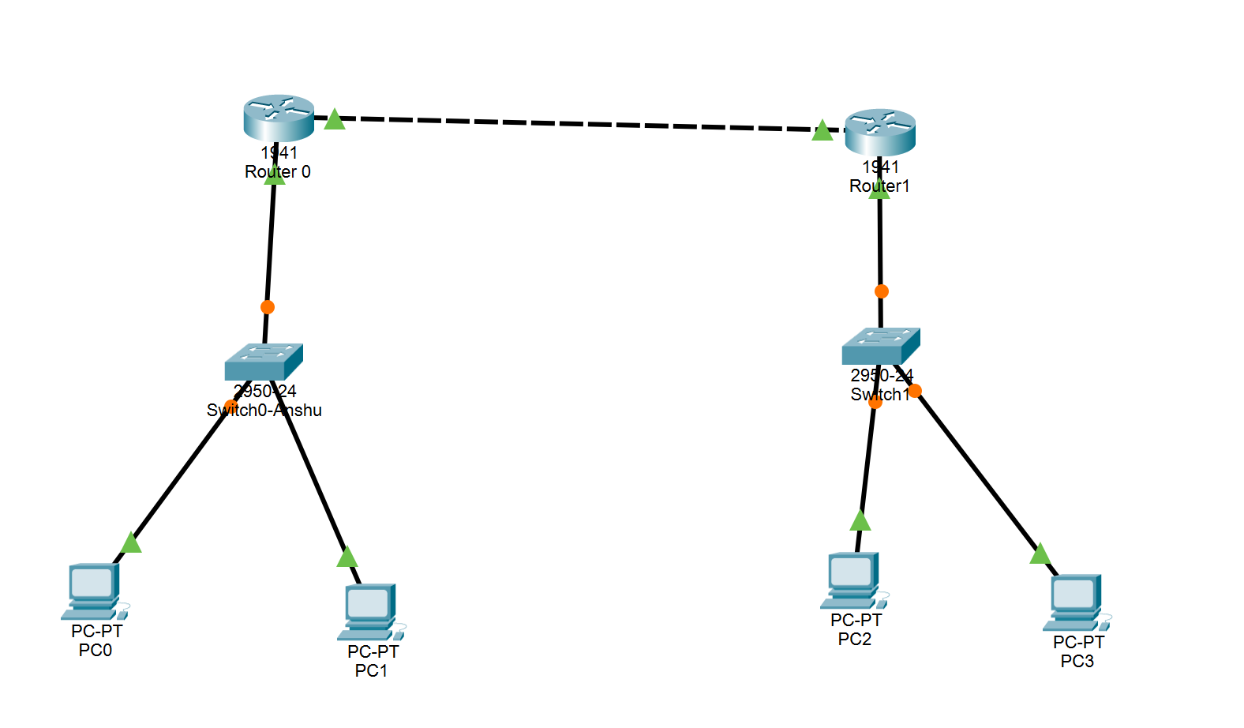

CONFIGURATION TABLE
Device | Interface | IPv4 Address | Subnet Mask | Default  Gateway
Router 0 | GigabitEthernet0/0 | 10.0.0.1 | 255.0.0.0 | N/A
Router 0 | GigabitEthernet0/1 | 192.168.1.1 | 255.255.255.0 | N/A
Router1 | GigabitEthernet0/0 | 10.0.0.2 | 255.0.0.0 | N/A
Router1 | GigabitEthernet0/1 | 192.168.2.1 | 255.255.255.0 | N/A
PC0 | FastEthernet0 | 192.168.1.2 | 255.255.255.0 | 192.168.1.1
PC1 | FastEthernet0 | 192.168.1.3 | 255.255.255.0 | 192.168.1.1
PC2 | FastEthernet0 | 192.168.2.2 | 255.255.255.0 | 192.168.2.1
PC3 | FastEthernet0 | 192.168.2.3 | 255.255.255.0 | 192.168.2.1

ROUTING CONFIGURATION
Device | Routing Type | Command / Route
Router 0 | Static Route | ip route 192.168.2.0  255.255.255.0 10.0.0.2
Router1 | Static Route | ip route 192.168.1.0  255.255.255.0 10.0.0.1
Router 0 | Default Route (Alt) | ip route 0.0.0.0 0.0.0.0  10.0.0.2

OBSERVATION / PING TEST RESULTS
Test No. | Source Device | Destination Device | Result
1 | PC0 (192.168.1.2) | PC2 (192.168.2.2) | Successful
2 | PC1 (192.168.1.3) | PC3 (192.168.2.3) | Successful
3 | PC2 (192.168.2.2) | PC0 (192.168.1.2) | Successful
4 | PC3 (192.168.2.3) | PC1 (192.168.1.3) | Successful

RESULT
The network was successfully configured. To verify the connectivity, ping requests were sent from various PCs in the first network to PCs in the second network. All ping tests were successful, with packets sent and received without any loss. This validates that both the static routes and default routes are correctly configured and operational.
The routing tables on both routers were examined and confirmed to contain the appropriate static route entries. Traffic successfully traversed the serial link between Router 0 and Router1, demonstrating proper inter-network communication.

DISCUSSION AND CONCLUSION
During the lab session, we implemented the concept of static routes and default routes to better understand how routers forward packets between different networks. Static routing allowed us to manually define the path for data transmission, ensuring security and control. Default routing helped in simplifying the routing table for the stub network.
The ping tests demonstrated that packets successfully traveled from the source network (192.168.1.0/24) through Router 0, across the serial link (10.0.0.0/8), through Router1, and finally to the destination network (192.168.2.0/24). This confirms that the routers correctly consulted their routing tables and forwarded packets based on the manually configured static routes.
Key learnings from this lab include:
- Static routes provide predictable and secure routing paths
- Default routes simplify configuration for stub networks
- Manual route configuration requires careful planning and documentation
- Ping testing is an effective method to verify network connectivity
Hence the lab was completed with a proper knowledge and implementation of static and default routing using Cisco Packet Tracer.

